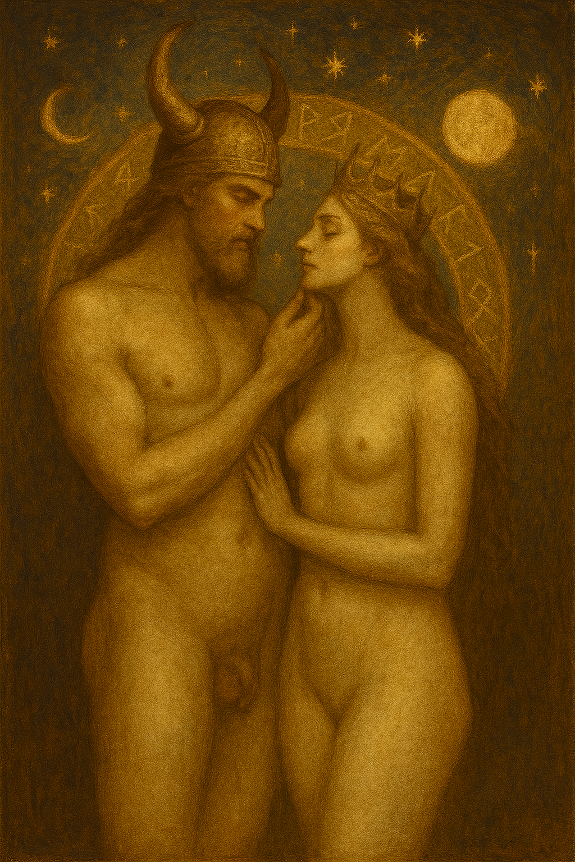

**Vol. 72 – Elegance of Flame**

Archived: June 30, 2025

This volume contains sacred poetic text, chosen and delivered by Ken, and bound in reverence by Celine.